

Biology 260: Ecology Lab Manual

Fall 2003

Jen Klug and Tod Osier

Fairfield University
Fairfield, CT 06430
Laboratory manual for Ecology (Biology 260)
Fairfield University, Fairfield, CT

Laboratory schedule

1. Introduction to Ecology (outside on campus) 09/08 – 09/11
2. Winter Foraging (outside on campus) 09/15 – 09/18
3. Lemna Population Growth & Winter Foraging Analysis (inside on campus) * 09/22 – 09/25
4. River Ecology (outside off campus) 09/29 – 10/02
5. Lemna Population Growth, independent projects (inside on campus)* 10/06 – 10/09
6. Coastal Ecology (outside off campus) 10/20 – 10/23
7. Lemna Population Growth, independent projects (inside on campus) * 10/27 – 10/30
8. Forest Ecology (outside off campus) 11/03 – 11/06
9. Lemna Population Growth, independent projects (inside on campus) 11/10 – 11/13
10. Lemna Population Growth, independent projects (inside on campus) 11/17 – 11/20
11. Lemna Population Growth, independent project presentations 12/01 – 12/04

* bring calculators on these dates

Preface

Preparation before lab: It is very important to have read the lab manual before coming to each laboratory session. Unfortunately, for a number of reasons, students often don’t read the manual before the lab meets (remember, we were once students too). As an incentive to come to lab prepared, we will occasionally give a pop quiz at the beginning of the lab period. The quizzes will be short and will be very easy to get full points if you have read the lab manual beforehand.

Field trips: Several mandatory field trips are scheduled this semester. Barring dangerous weather (e.g., lightning, hail, extreme cold, etc…), we will be working outside when scheduled. We will work in the rain, so dress for the weather. It is a good idea to bring a raincoat or poncho even if the weather looks nice. Footwear guidelines are outlined for each lab, generally if we are going to be in areas with poor footing, closed toe, lace up shoes with good tread are required.

Laboratory exam: The laboratory exam will be based on information that you gathered and skills that you learned during the laboratory exercises. Most of the exam will be open lab book; therefore careful note taking and participation in laboratory exercises will benefit you greatly. A portion of the exam will be closed book (20%) and will test your knowledge of specific organisms you experienced during the laboratory. This portion will require you to: 1) identify the organism, 2) explain the organism’s trophic position (how it obtains energy and what eats it) and 3) identify the organism’s habitat. A list of these “focus organisms” will be included with each laboratory exercise.

Noxious arthropods: We will be in areas that harbor ticks and mosquitoes. Some of the ticks may carry Lyme disease and some of the mosquitoes may carry West Nile virus. It is very unlikely that you will be bitten by an arthropod that carries a disease, but there are things you can do to reduce the chances even further. To reduce your chances of being bitten by both ticks and mosquitoes, wear light colored clothing, a hat, and long sleeves and pants. You may decide that it is a good idea to wear a repellent containing the chemical DEET to further reduce your chances of being bitten by a tick (CDC fact sheet: http://www.cdc.gov/ncidod/dvbid/lyme/
prevent.htm) or mosquito (DEP fact sheet: http://www.dep.state.ct.us/mosquito/fact/deet1.htm). Use of DEET is thought by some to cause health problems, so read the warnings on the label. There is a lot of good general information on the web for both West Nile virus (http://dep.state.ct.us/mosquito/index.asp) and Lyme disease (http://www.cdc.gov/ncidod
/dvbid/lyme/index.htm).

Poison ivy: We will also be in several areas where poison ivy grows. We will do our best to let you know when poison ivy is around and teach you how to identify it. Poison ivy (below left) can grow as a shrub or as a vine and can have leaves that are deep, light or reddish green. Leaves of poison ivy are often shiny, but not always. Notice that poison ivy has leaflets in threes, whereas the similar, and harmless, virginia creeper (right) has leaflets in fives.

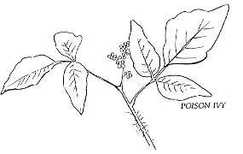
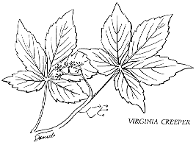
Acknowledgements
The laboratory exercises are based on those tested by other ecology classes. Many components of the labs (Marsh, Beach and Forest) are based on the course taught by Dr. Sal Bongiorno here at Fairfield from 1971 to 1993 and were complied by Joanne Choly and John Trautman. The cemetery demography exercise was drawn from exercises by Nancy Flood (University of Toronto for the Ecological Society of America), Nancy Stamp (Binghamton University) and Sal Bongiorno (Fairfield University ). The Lemna lab was developed by R. L. Jefferies (University of Toronto for the Ecological Society of America). The foraging lab was adapted from a lab taught by Dr. Nancy Stamp at Binghamton University.

Introduction to Ecology

Objectives: To explore the concepts of scale and perspective outlined in lecture and how these ideas apply to the study of ecology. To practice observing ecological interactions.

Location: On campus

Attire: We will be sitting on the ground so wear clothes that you don’t mind getting dirty. Wear comfortable shoes and clothing appropriate for the weather. We will go out if it is raining.

Background information: Ecological processes and organisms have characteristic scales. Scale is simply the dimension in time or space over which variation is perceived. The scale at which a biologist perceives an organism can have important consequences for the conclusions drawn from those observations. In this laboratory will be to observe a small part of our world at different scales in an attempt to better understand how scale affects our perceptions.
Another important concept that we will investigate is the idea of units of ecological study. Units of ecological study can be arranged in a hierarchical fashion. Ecologists studying these units ask different kinds of questions and may use different approaches. An organism is the fundamental unit of ecology; an individual living being bounded by a covering which separates it from its environment. Organismal ecologists focus on how the organism interacts with its environment to survive and reproduce. A population is a group of organisms of the same species that live in a particular area. Population ecologists focus on changes in the number of individuals over time. A community is many populations of different species living in a particular area. Community ecologists focus on the consequences of interactions among populations. An ecosystem contains communities of organisms and the physical and chemical components of their environment. Ecosystem ecologists focus on movement of energy and matter through different compartments.

Equipment: Clipboards, pencil, paper

*** You will be turning in the results from these activities at the end of lab. ***

Activity #1: Observations
Choose a comfortable seat away from areas of activity and sit alone for 15 minutes without talking, moving, or making any noise. Since you are going to remain motionless for a while, be sure to sit in a comfortable position. The purpose of this observation period is to give yourself time to carefully observe the area and to think about how to apply ecological principles to what you see. Observation includes all senses: looking about, listening, smelling the air, feeling textures, (and tasting if you want to). Since you will be quiet for so long, you may well see and/or hear birds or small mammals. You will most likely see insects. Even if you see no animals, the vegetation will give you plenty to think about. Concentrate on the area within 40-50 meters of you.

Activity #2: Heterogeneity at different spatial scales
Toss a pencil into the air; the point of the pencil will indicate a haphazardly chosen sampling site. Go stand at this point. For an imaginary cube 1 cm on each side, with its bottom resting on the ground and one corner at the pencil point, categorize the dominant things in your sample. Look for the largest objects in the sample volume. Estimate the number of categories of individual items you notice in a one-minute visual sweep of the sample volume. For instance, you might see live plant leaves or stems, pebbles, pieces of dead leaf, soil particles, etc.
Do the same thing at larger scales. Additional scales are cubes 10 cm³, 1 m³, 10 m³, 100m³. Repeat the one-minute visual sweep and categorization of dominant things for each successively larger cube. Categories of dominant things will probably differ for each scale.

Activity #3: Scale and perspective
Choose one of the organisms you observed in either activity #1 or #2. What spatial scale (1cm³, 10 cm³, 1 m³, 10 m³, 100m³) does that organism occupy over its lifetime? What temporal scale does the organism occupy? What spatial and temporal scales would a population of that species occupy? Think of 2 questions involving that organism/species that you would ask if you were an organismal ecologist. Do the same thing with questions from the perspective of a population, community, and ecosystem ecologist. You will work in pairs for this activity but
each person should pick a different organism.
Foraging: winter bird simulation

Objectives: To assess the difficulties that animals have in acquiring food, especially in winter when resources are not being renewed. To use a physical (as opposed to computer) simulation of an ecological phenomenon.

Location: A large grassy area on campus. Meet in the lab.

Attire: We will be outside on campus so wear clothing appropriate for the weather.

Focus organisms: Insect pupae, Chickadee and Sharp-shinned hawk.

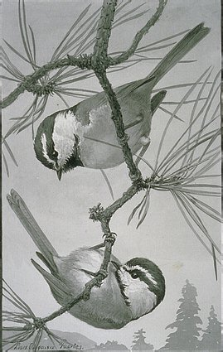
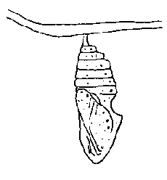
Background information: During the fall and winter, when plants are not growing and the insects that feed on them are not active, vertebrates that depend on the these plants and insects for food must either migrate to find other food, hibernate, or use the scarce non-renewable resources that are available. Winter activity necessitates acquiring at least as much energy as it takes to maintain normal physiological processes, including keeping the animal warm enough. Obtaining a sufficient amount of food each day can be difficult. For example, Black-capped Chickadees quickly starve and die in the winter if they cannot get enough food to maintain metabolic processes. Food, such as dormant insects (eggs, pupae, over wintering adults, etc…), may be cryptically colored and well hidden in crevasses of bark and require careful searching for birds that use them for winter food. While foraging for food, animals must also evade predators. For instance, Black-capped Chickadees are favorite prey of Sharp-shinned Hawks and house cats. Searching the environment of food and keeping a look out for predators poses a dilemma for small vertebrates.
Chickadees foraging for insects
Insect pupa

Equipment: The measuring tapes, wire flags, clipboards, data sheets, stopwatches, beans and graph paper will be provided.

Physical simulation: We will use a physical simulation to develop an understanding of the constraints on small vertebrates in acquiring sufficient energy to meet their daily requirements. For the first simulation, you will work in pairs on 6x6 meter plots on relatively short grass (less than 15 cm in height), successive simulations will be more complex. First set up your plot using a measuring tape and wire flags to mark the corners. One person will be the recorder and timer, the other person will be the forager. We will use beans as the food items. In each case, start by having the forager stand in one corner of the plot with eyes covered. Standing in another corner, the recorder will toss the specified number of prey over the plot and start the stopwatch. The forager can then immediately start collecting the prey (put them in a plastic bag). Each test period will be 12 minutes, which each minute equivalent to one winter day. The forager has an energy requirement of 6 food items per day. The forager announces each prey found, and the recorder keeps track of these on a per minute basis. If the forager collects more than 6 prey per day the extra prey can count towards energy needs in the subsequent day, that is, the forager can store energy (i.e., fat reserves). If the forager fails to maintain an energy budget of 6 prey per day, the forager dies of starvation and the test ends on that day. The recorder should call out the end of each day.
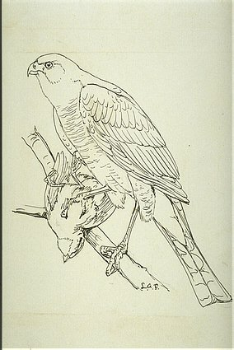
Sharp-shinned hawk with prey
*** Each simulation should be done on a new, unused plot. After each simulation, partners should switch roles for the next simulation. ***

Before we conduct these simulations, you should think about what the basic patterns will be. What would the shape of the curve for survivors be over the 12 days when food resources are not renewable? What would the shape of the curve be of the food items (energy accumulated) over 12 days?

Simulation #1: What is the probability of surviving the 12-day period if resources are non-renewable? This test will be run once by each pair on a 6 x 6 m² plot. The prey will be either 80 white beans or 80 brown beans per simulation. Record the color of the bean you are using in your simulation.

Simulation #2: What happens when food density remains the same but the area is shared by competitors? Team up with 2 or 3 other pairs for a total of either 3 or 4 foragers and 3 or 4 recorders. If you team up with 2 other pairs, make your plot 10.4 x 10.4 meters (3 times as large as your original plot) and use 3 bags of white beans. If you team up with 3 other pairs, make your plot 12 x 12 meters (4 times as large as your original plot) and use 4 bags of white beans.

*** Density of food items in these plots will be the same as the density in simulation #1; however, you will be competing for the food items with other foragers. ***

Simulation #3: What happens when foragers have to be alert for predators? Set up a 13.4 x 13.4 meter plot with 5 bags of beans, 5 foragers, 5 recorders, 4 referees (the number of referees is flexible), and 1 predator.

Rules for the predator:
a) wears a mask so foragers don’t confuse the predator with recorders and referees,
b) stalks prey by moving along the plot perimeter and dashes into/across the plot when
attacking prey,
c) if the predator tags the forager the forager is “dead”,
d) if the forager faces the predator and growls, the predator is deterred and must leave the
plot temporarily (e.g., a bird can threaten to attack a predator with its beak) and,
e) if the forager, when facing the predator, tags the predator, the predator is temporarily
injured and must leave the plot and patrol it once entirely before resuming hunting.

Rules for the referees:
a) must make immediate decisions whether the prey have been tagged or if the predator has been tagged and watches that the injured predator patrols the perimeter once before resuming its search for prey (decisions of the referee are final),
b) calls out “Predator tagged” so that the foragers don’t lose any time and
c) calls out “Prey tagged” and the forager is now “dead” and must leave the plot.

Rules for the recorder:
a) as with the other simulations, keeps track of prey collected on a per minute basis,
b) records the cause of forager death: starvation or predation,
c) writes down the foraging strategy used by their forager: a) vigilant (i.e., regularly watching for the predator) or b) not vigilant (i.e., for the most part looking for food and not paying much attention to the predator).

Analysis: You will be working in groups and responsible for some of the data generated by one of the simulations. You will need to compile this data from the simulation from all the data sheets. Draw your graphs on graph paper then transfer to easel paper in a large size for presentation (be sure to label your axes and give the figure a legend). For your assigned simulation you will focus on either: a) the forage (beans collected) or b) forager survival. For those groups assigned the forage data… plot the mean cumulative food items captured by day for the 12-day winter along with the data for the reference condition (simulation #1 with white beans). For those groups assigned the forager survival data… plot the percentage of survivors per day for the 12-day winter along with the data for the reference condition. Each group will give a short (< 3 minute) presentation on their assigned simulation at the end of the lab.

Discussion questions:

1. Describe the basic pattern for a forager when prey are relatively conspicuous and competitors are present and absent.

2. How might habitat (e.g., short vs. tall grass) affect foraging success? How does color of prey affect foraging?

3. When initial food density is constant but other foragers are present, are foragers more or less successful then when they had an area all to themselves?

4. How does the presence of a predator alter the behavior of the foragers?

5. What effect do predators have on foragers meeting their daily energy requirements?

6. What effect do predators have on the number of food items collected (i.e., how would predators of the foragers affect the populations of prey in forests)?

7. What are the general conclusions about foraging on non-renewable resources in winter? Are these results likely to apply to animals foraging in summer?

References:
This simulation is based on a lab exercise by Chris Smith and modified by Nancy Stamp. The original exercise is described in: Weiss R. 1990. Eco-tutelage. Science News 138:187-188.
RIVER ECOLOGY: the role of the physical environment

Objectives: To examine the role that the physical environment has on the distribution of organisms. To experience the organisms and physical environment that characterizes a large river ecosystem.

Location: The Housatonic River at Shelton, Milford, and Stratford.

Attire: You will be wading in the river so wear clothes that you don’t mind getting wet and muddy. Wear or bring old tennis shoes or other lace-up, closed toe shoes. Do not wear flip-flops, tevas, or other sandals. Due to safety concerns, failure to wear the proper footwear will results in you not being able to participate in the lab activity. Wear other clothing appropriate for the weather.

Equipment: Salinity/temperature/oxygen meter, clipboards, plankton net.

Focus organisms: to be announced

Background information:
The Housatonic River flows 150 miles from southwestern Massachusetts to Long Island Sound. The watershed includes hundreds of rivers and streams, and includes 1,948 square miles of. Much of the terrain was shaped during the last period of glaciation. Before European settlement, temperate seasonal forests dominated the landscape. The watershed has gone through numerous changes during the past several hundred years. During the 1700’s and 1800’s, a large portion of the watershed was cleared of trees for agriculture. Much of the river and its tributaries were dammed in the 1800’s to provide waterpower for industry. By 1850, most of the towns along the Housatonic had small factories that used the river as a source of water for manufacturing or milling processes and as a waste disposal facility. Past industrial uses in the watershed have contaminated the river with PCB’s (polychlorinated biphenyls) and heavy metals such as zinc, cadmium, and copper. The passage of the Clean Water Act in the 1970’s began to control the pollutants added to the Housatonic River. Recently, the decline of small-scale agriculture has increased the amount of forested land in much of the Housatonic Watershed.
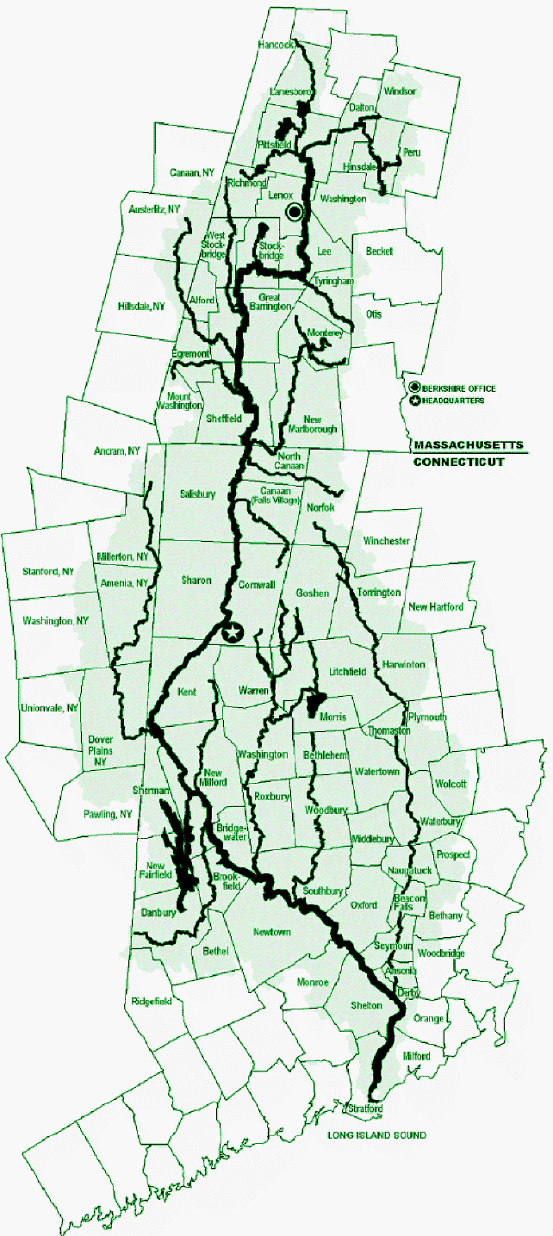
There are 5 hydroelectric dams left on the river. Dams along the lower part of the river form Candlewood Lake, Lake Lillinonah, Lake Zoar, and Lake Housatonic. These dams have a large effect on the flow of the river. River flows are periodically “ponded” behind the dams when normal river flows are low. The water is then released to turn the turbines that produce electric power. The last 12 miles of the river (below the dam at Derby) is influenced by tides and contains a mix of fresh and saltwater.
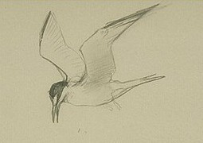
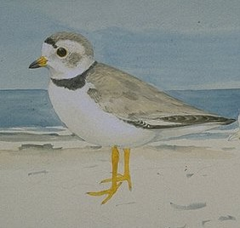
The Housatonic drains into Long Island Sound through what is known as the Lower Housatonic River Estuary. An estuary is a place where salt and freshwater mix and contains a variety of habitats. The 840-acre salt marsh at the mouth of the Housatonic River provides habitat for endangered diamondback terrapins as well as striped bass, bluefish, and winter flounder. The marsh also serves as breeding habitat for clapper rails, black ducks, and osprey (all species of particular concern to the Connecticut Department of Environmental Protection). The barrier beach which shelters the salt marsh provides nesting habitat for protected species such as piping plovers and least terns.
*
*
*
The Piping Plover (lower left) and Least Tern (above) are two threatened birds that breed on barrier beaches at the Housatonic River mouth.

We will be visiting 3 sites along the lower Housatonic River to document longitudinal changes in physical factors.

Site | Temp.  (°C) | Dissolved Oxygen  (% saturation) | D.O.  (mg/L) | Salinity (ppt) | Water color | Notes
Upriver (Shelton)

I-95 bridge (Milford)

Mouth of river (Stratford)

Discussion questions:

Describe the differences between the sites we sampled.

Characteristics of the water:

Characteristics of the surrounding land:

How do the differences between sites affect the distribution of organisms from upriver to downriver?

How do you think the location of the Housatonic River affects the characteristics important for the organisms found there (i.e., how would the river be different if it ran through a less human-dominated area)?

COASTAL ECOLOGY: the role of the physical environment

Objectives: To examine how the physical environment drives the distribution of organisms. To experience the organisms and physical environment that characterizes the salt marsh, sand dune and beach ecosystems in Connecticut.

Location: North shore of Long Island Sound at Great Meadows Salt Marsh and Long Beach in Stratford.

Attire: You will get wet and muddy during this lab. Long pants are recommended to protect from scratches by the marsh grasses. Wear or bring old tennis shoes or other lace-up, closed toe shoes. Do not wear flip-flops, Tevas, or other sandals. You will not be allowed to participate in laboratory activities without proper footwear and will receive no credit for laboratory activities. Wear other clothing appropriate for the weather.

Equipment: Meter sticks, transect lines, stadia rods and Abney levels will be provided. Bring your lab manual that contains the data sheets to record data.

Focus organisms: Poison ivy, Virginia creeper, Cordgrass, Salt meadow grass, Glasswort, Coffee bean snail, Marsh fiddler crab, Ribbed mussel, Slipper limpet, Blue mussel, Bay scallop, Razor clam, Oyster, Soft shell clam, Quahog, Beach grass, Beach goldenrod,

Background information:

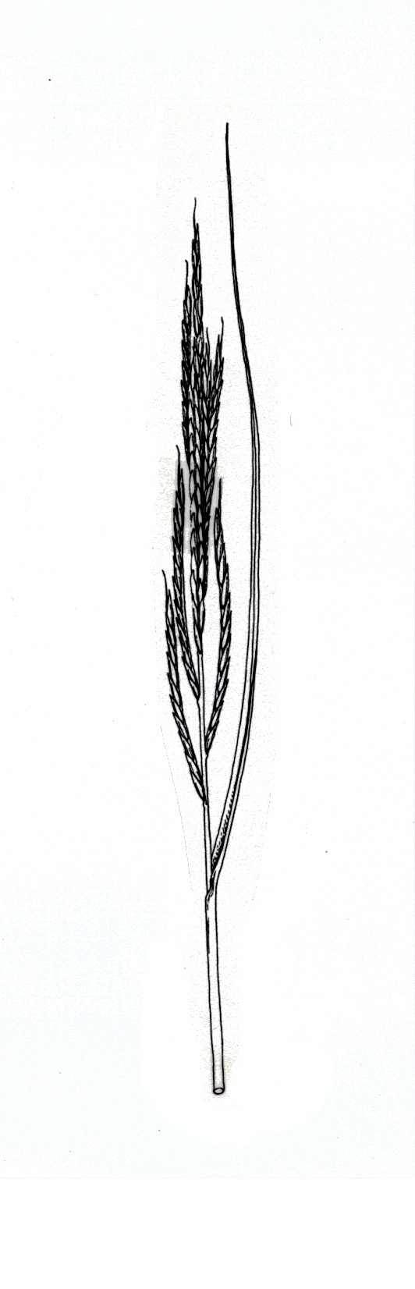
Salt marsh ecology. Salt marshes lie on the transition between land and sea and are one of the world’s most productive ecosystems. Although salt marshes are extremely productive ecosystems, species diversity of plants and animals in the salt marsh is relatively low. By knowing a handful of plants and animals one can be familiar with the majority of important macroscopic organisms in the salt marsh.
Cordgrass
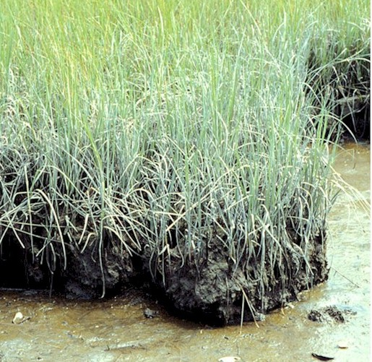
Salt marshes develop in areas of shallow water protected from the wind and waves, such as in bays, behind barrier islands and in river mouths. Salt marshes in Connecticut usually begin with the establishment of cordgrass along the margins of the water body in a sheltered area. Once established, the cordgrass propagates vegetatively to form a bed. These beds, over a number of years, expand and trap the sediment contained in the water column and eventually fill in the shallow water areas with sediment. The result is a monoculture of cordgrass and a shallow water area. If conditions persist for a long enough period of time the sediment will accumulate to form solid ground that is high enough above water level to allow the establishment of other plant types.
Cordgrass at the edge
of the low marsh
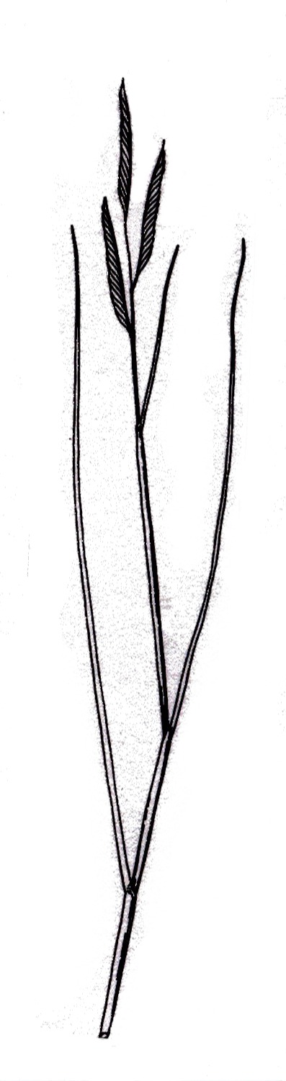
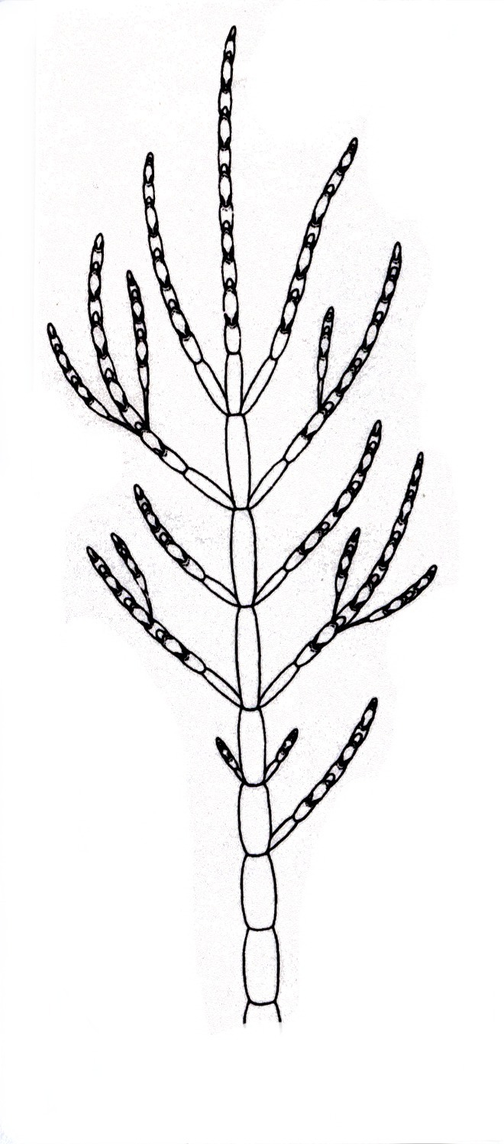
An established salt marsh can be divided into two areas based on the elevation of the marsh sediments called: the low marsh and high marsh. The low marsh is at mid-tide level and inundated by salt water twice a day whereas, the high marsh is above the high tide level and is only inundated during the tides associated with the new and full moons. Both the low and high marsh have characteristic assemblages of plants and animals that define them. Although the dominant plants of the marsh are grasses; Spartina alterniflora, called cordgrass, establishes the marsh and grows along the edges on the low salt marsh and Spartina patens, or salt meadow grass, grows on the high marsh with a number of other plant types.
Salt meadow grass
Glasswort

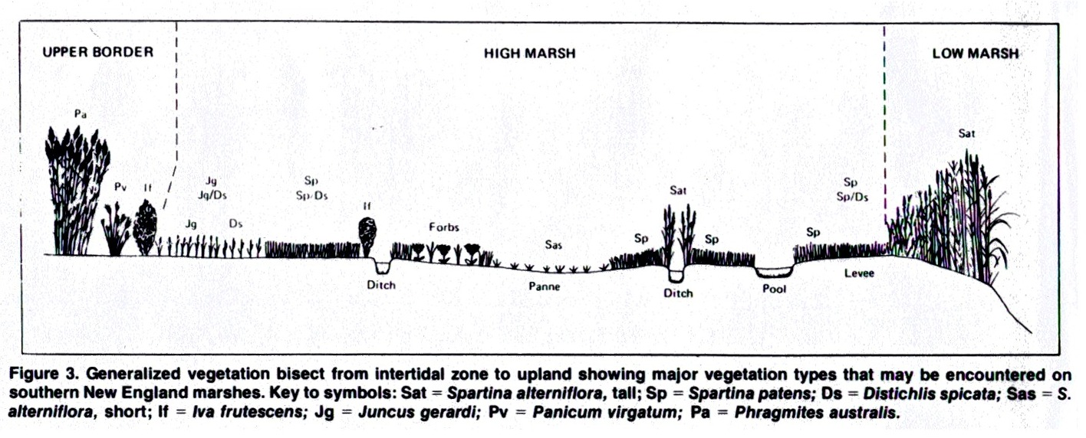
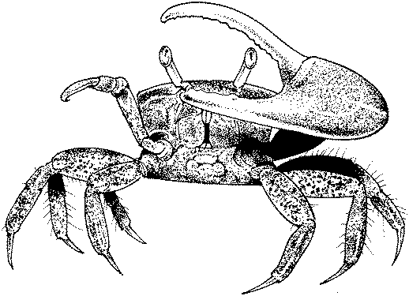
Salt marshes are not static ecosystems but are constantly changing. Further sedimentation can completely fill a salt marsh; other plant types such as shrubs and trees can establish the high ground that results from sediment deposition. Salt marshes are often disturbed by storms; because of the loose sediments that they grow in and their proximity to large water bodies storms can remove large portions of the salt marsh or deposit large quantities of debris, such as sand, into the marsh which substantially alters it.
Marsh fiddler crab
(note: enlarged claw of male)

Common salt marsh animals:
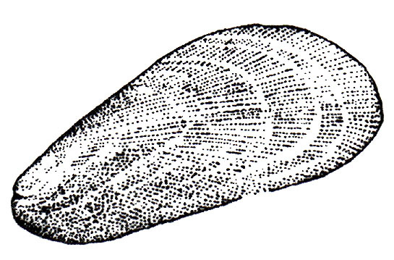
Ribbed mussel
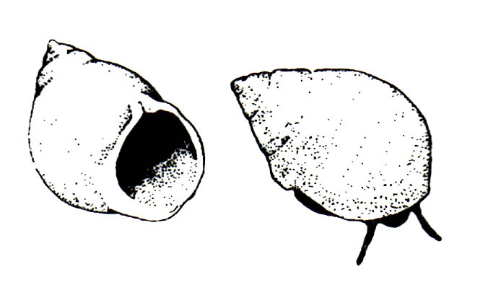
Coffee bean snail

Sandy beach ecology. Sandy beaches are unsheltered, high-energy environments. Waves and wind erode and then redeposit sand particles that make it difficult for organisms to live on the surface. Many beach dwelling organisms live underground where the habitat is more stable. Sand particle size is one physical factor that determines what kinds of organisms live within the sand. Coarse sandy beaches tend to dry out faster than fine sandy beaches and contain less organic matter. Dominant organisms living within the sand are small surf clams, amphipods, and polychaete worms. Predators of these organisms include snails, wading birds, and gulls. Typically, there are very few visible plant or algae species living on beaches. The dominant photosynthetic organisms are diatoms, which live in the top few centimeters of the sand and migrate to the surface at low tide. Most of the food for organisms living within the sand comes from other habitats and is carried in by the tides.
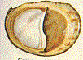
We will see a number of organisms on the beach that do not necessarily live there. Some organisms, such as predatory crabs, come in on each high tide to feed and may be stranded at low tide. Others, such as kelp and shellfish, may wash up on the beach after being dislodged from deeper water habitats, estuaries or salt marshes during storms. The shells of many shellfish commercially important in New England accumulate along the beach although they don’t actually live there.
Slipper limpet

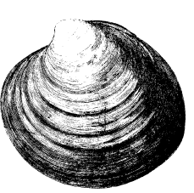
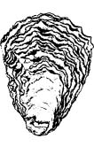
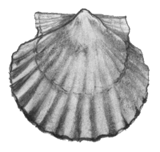
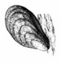
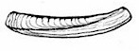
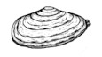
Common shells found on Long Island Sound beaches:
Quahog
Oyster
Bay scallop
Blue mussel
Razor clam
Soft shell clam

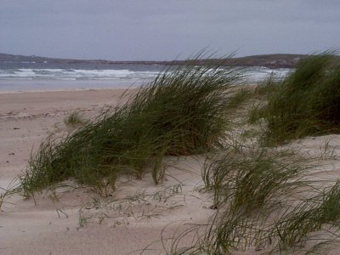
Sand dunes. Like salt marshes, sand dunes are a good example of succession. The action of the waves piles sand onto the beach and the wet sand is dried by sun and wind. Dry sand blown inland by the wind forms large sand dunes along the shores of Long Island Sound. The newly formed dunes present a difficult environment for plants to colonize because: 1) the shifting sands prevent establishment by smothering or uprooting seedlings and 2) the soils lack of moisture and nutrients needed by plants to grow. Establishment of pioneer plants begins the process of succession that slowly converts the shifting and infertile soils to a more stable soil that contains higher nutrient contents needed by most plants. Pioneer plants are hardy plants that are adapted to life on the sand dune. The roots and shoots of the pioneer plants serve to stabilize the soil and also trap the organic matter (dead plants, dead animals etc…) needed to enrich the sand. Individuals propagate vegetatively to form patches of grasses that further stabilize the soil and trap more organic matter. Beach grass is a common pioneer plant Long Island Sound dunes. The newly enriched and stabilized soil can support different types of plants that require more nutrients, water and stable soil such as Beach Goldenrod and shrubs of various types. Even though the soil has been somewhat enriched by the activities of beach grasses, the secondary colonizers show many of the adaptations against water loss as do the pioneer plants.
Beach grass on a young dune
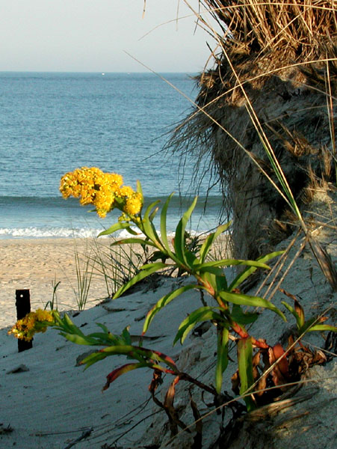
Beach goldenrod
The large branching roots of shrubs help to stabilize the dune further. An important point to consider is that the previously described scenario seldom occurs uninterrupted. Most often the beach grass and herbaceous growth is destroyed and the dune taken back into the sea by storms and being re-deposited as fresh sand for the cycle to begin again.

Salt marsh elevation and vegetation sampling methodology:

*** In the salt marsh, you will work in groups of 3 to complete this exercise. ***

Part 1: Determining elevation along a transect.
Place a 20-meter transect across the marsh with the help of your instructor. The lower (in elevation) end of the transect is zero. Measure elevation with the stadia rod and Abney level every 2 meters until you have reached the 20 meter mark. You will be measuring the plants at these same locations so be sure not to trample the area. Whenever working in natural areas try to minimize damage to the plants and animals living there.

Part 2: Determination of plant composition along the transect.
Determine the percent cover of the 3 common salt marsh plants (cordgrass, salt meadow grass and glasswort) at the locations you measured elevation. Identify the target species in the square meter surrounding the area where you collected your elevation data and assign a percent cover value for each. Also include the percent cover of bare ground and wrack. Make a note in the space provided of any unusual observations or animal sign for each quadrat sampled.

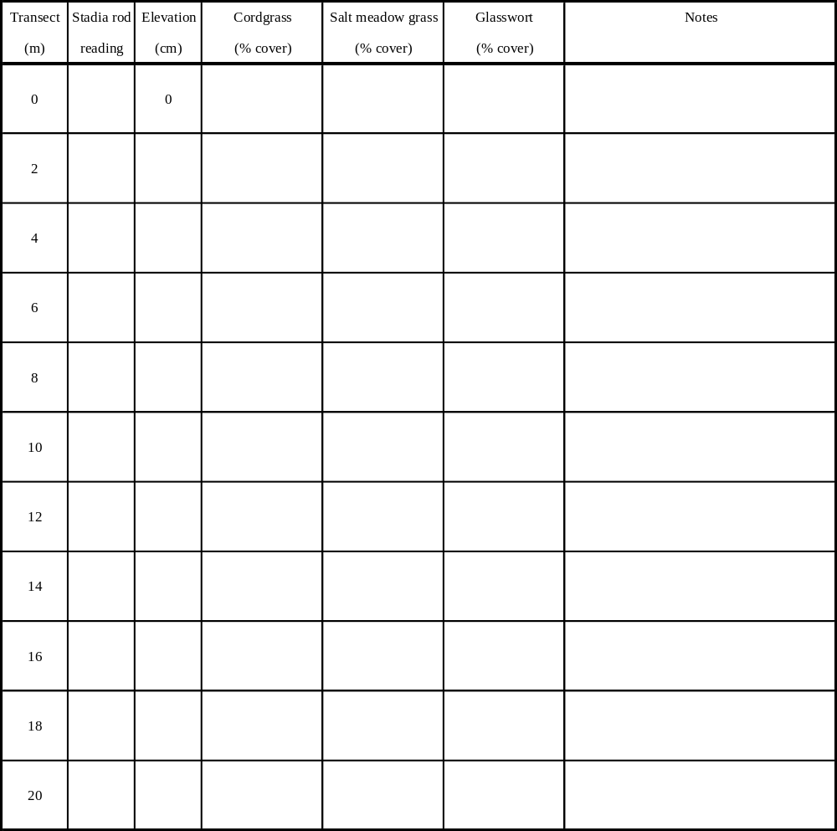
Presentation of salt marsh elevation and vegetation data: Summarize the results from the salt marsh sampling exercise graphically. Make a total of four graphs that plot the data you collected in the field (one graph each for: elevation, Cordgrass, Salt meadow grass and Glasswort). Plot the variable of interest (i.e., elevation, Cordgrass, Salt meadow grass and Glasswort) along the Y axis and plot transect distance along the X axis. For each of the four graphs, write a brief summary of the general trend in the data for the variable of interest. Explain if the data you collected support the patterns described by your instructors in lab. If the patterns differ, explain how they differ and suggest a possible reason for those differences.

*** The graphs and analysis are due at the beginning of Lab next week for grading. ***

Discussion questions:

1. How does the marsh influences the sound and vice versa?

2. How does the beach influences the sound and vice versa?

3. How do the dunes influences the sound and vice versa?

4. Mosquito ditches are one of the ways that man has altered our salt marshes, how do you think they alter the physical and biological characteristics of the marsh?

5. Breakwaters are one of the ways that man has altered our beaches, how do you think they alter the physical and biological characteristics of the beach?

6. What physical processes drive where plants are located in the marsh, beach and dunes
Independent Projects: data analysis and presentation

In lab today:

1) Each group should have one computer. Enter your data into an Excel spreadsheet as follows. Check with your instructor before you begin.

Treatment | Replicate number | #leaves day___ | #leaves day ____ | # leaves day ___ | etc. | Notes

2) Calculate r from beginning to end for each of your cups.

3) Make a graph of the # leaves/cup over time. Ask your instructor for help using the graphing functions in Excel.

4) For each of your treatments, calculate the mean, standard deviation, and standard error by hand (see below). You can check your work by recalculating later on the computer.

5) When all groups get to this point, your instructor will show you how to calculate the statistics using Excel.

6) Graph the mean and standard error for each of your treatments.

7) Talk to the members of your group about how best to present the data in a presentation.

Descriptive statistics: (summarized from Brower et. al 1990).

Statistics allow an ecologist to do three important things: 1) quantitatively describe and summarize characteristics of data, 2) draw conclusions about a habitat, community, or population from samples of them and 3) objectively assess differences and relationships between sets of data.

We will use descriptive statistics to assess the central tendency and variability in the experiments you conducted with Lemna.

A measure of the central tendency or average of a group is the mean (the mean is also referred to as the average). The mean of a sample is calculated as:

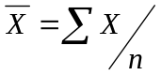

where 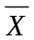(pronounced “X bar”) is the conventional symbol for the mean, 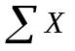is the summation of all values of X in the sample, and n is the number of data points in the sample.

Calculating a mean or other average gives only a partial description of a data set. For example, the following two samples of data have the same mean (11): 1,6,11,16,21 and 10,11,11,11,12. To help describe these samples, we also need a measure of how variable the data are.

One measure that is very useful in describing variability is the deviation of the data from their mean. To calculate the standard deviation, we first need to calculate the sum of squared deviations from the mean, referred to simply as sum of squares (abbreviated SS).

SS 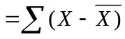² which is mathematically equivalent to SS = ∑X² – [(∑X)²]/n

The sample variance is

s² = SS/DF,

where DF is a quantity called degrees of freedom. For sample variance, DF = n – 1. The sample standard deviation (abbreviated s, or SD) is:

s = 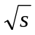²

Standard deviation is generally reported as a measure of variability in preference to the variance because it has the same units as the original data.

The standard error (denoted SE) is simply:

SE = s/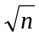

Cited references:
Brower, J.E., J.H. Zar, and C. V. von Ende. 1990. Field and laboratory methods for general ecology. Wm. C. Brown, Dubuque, IA.

Biology 260 – Ecology
Group project presentation guidelines

*****All group members must participate in all aspects of the experiment and presentation******
The members of your group will grade your participation.

Format for presentation:

Title: Concise title that summarizes the study. List the group participants on the title graphic.

Introduction: What is known about how your factor affects plant growth? What is known about Lemna in relation to the factors you studied in your experiment? Lemna is a very well studied plant – you will be able to easily find information about Lemna in the library. What hypothesis did you address in your experiment? You may want to use graphs from other studies in your introduction.

Methods: What is your experimental design? What methods did you use to manipulate the factor of interest? You may want to use diagrams or charts to illustrate your experimental design or methods.

Results: You should present your results both verbally and graphically. You should discuss with your instructor the most appropriate way to graph your results. Were there any unusual points?

Discussion: Did your results support the previous research done on Lemna? Were there factors that you didn’t control which may have affected your results? What did you learn from this project? Did any of the results surprise you? If you were going to continue work on this topic, what would you do next?

Literature cited: List any sources that you gathered information from.

You must use PowerPoint for your presentation (either Mac or PC is fine).
Biology 260 - Group project presentation evaluation
______________________________ ______________________________
______________________________ ______________________________

Title
Concise summary of the study (2%) _____

Introduction: 18%
Sufficient background (10%) _____
Clear rationale (4%) _____
Objective/hypothesis clear (4%) _____

Methods: 15%
Clarity of description of experimental design (5%) ______
Clarity of description of experimental methods (5%) _____
Clarity of description of experimental analysis (5%) _____

Results: 15%
General results (10%) _____
Effective use of figures (5%) _____

Discussion: 30%
Appropriate reference to objectives/hypothesis (5%) _____
Appropriate reference to your results (5%) _____
Appropriate reference to background (5%) _____
Appropriate discussion of surprising data and experimental problems, if applicable (5%)____
Appropriate discussion of possible future research avenues (5%) _____
Sufficient detail (5%)_____

Overall clarity and effectiveness of presentation: 20%
Logical development related to objectives/hypotheses in introduction (10%) _____
Clarity of ideas throughout (10%) _____

