Exam 2 Microeconomics

The exam is 15 multiple-choice questions and 3 short answer questions. Write your answers on a separate sheet of paper. List your multiple choice answers in one column. Good luck!

1.) Suppose Chris and Neil attend a charity benefit and participate in a silent auction. Each has in mind a maximum amount that he or she will bid for an oil painting by a locally famous artist. This maximum is called

a. deadweight loss.

b. willingness to pay.

c. consumer surplus.

d. producer surplus.

2.) Ania purchases a book for $6, and her consumer surplus is $2. How much is Ania willing to pay for the book?

a. $6.

b. $2.

c. $8.

d. $4.

3.) If the price of oak lumber increases, what happens to consumer surplus in the market for oak cabinets?

a. Consumer surplus increases.

b. Consumer surplus decreases.

c. Consumer surplus will not change consumer surplus; only producer surplus changes.

d. Consumer surplus depends on what event led to the increase in the price of oak lumber.

The vertical distance between points A and B represents a tax in the market.



4.) **Refer to Figure.** The imposition of the tax causes the quantity sold to

|  |  |
| --- | --- |
| a. | increase by 1 unit. |
| b. | decrease by 1 unit. |
| c. | increase by 2 units. |
| d. | decrease by 2 units. |

5.)  **Refer to Figure.** The amount of deadweight loss as a result of the tax is

|  |  |
| --- | --- |
| a. | $2.50. |
| b. | $5. |
| c. | $7.50. |
| d. | $10. |

6.) For any country, if the world price of beer is higher than the domestic price of beer without trade, that country should

a. export beer, since that country has a comparative advantage in beer.

b. import beer, since that country has a comparative advantage in beer.

c. neither export nor import beer, since that country cannot gain from trade.

d. neither export nor import beer, since that country already produces beer at a low cost compared to other countries.

7.) Assume, for Canada, that the domestic price of wheat without international trade is lower than the world price of wheat. This suggests that, in the production of wheat,

|  |  |
| --- | --- |
| a. | Canada has a comparative advantage over other countries and Canada will export wheat. |
| b. | Canada has a comparative advantage over other countries and Canada will import wheat. |
| c. | other countries have a comparative advantage over Canada and Canada will export wheat. |
| d. | other countries have a comparative advantage over Canada and Canada will import wheat. |

8.) Which of the following statements about a well-maintained yard best conveys the general nature of the externality?

|  |  |
| --- | --- |
| a. | A well-maintained yard conveys a positive externality because it increases the home's market value. |
| b. | A well-maintained yard conveys a negative externality because it increases the property tax liability of the owner. |
| c. | A well-maintained yard conveys a positive externality because it increases the value of adjacent properties in the neighborhood. |
| d. | A well-maintained yard cannot provide any type of externality. |

9.) Which of the following represents a way that a government can help the private market to internalize an externality?

|  |  |
| --- | --- |
| a. | taxing goods that have negative externalities |
| b. | subsidizing goods that have positive externalities |
| c. | The government cannot improve upon the outcomes of private markets. |
| d. | Both a and b are correct. |

***Figure*** The graph depicts the market for plastic.



10.) **Refer to Figure.** Suppose that the production of plastic creates a social cost which is depicted in the graph above. What is the socially optimal quantity of plastic?

|  |  |
| --- | --- |
| a. | 200 units |
| b. | 450 units |
| c. | 500 units |
| d. | 650 units |

11.) **Refer to Figure.** The production of plastic creates a social cost which is depicted in the graph above. What is the amount of the externality according to the graph?

|  |  |
| --- | --- |
| a. | $3.50 |
| b. | $5.00 |
| c. | $1 |
| d. | $2 |

12.) An optimal tax on pollution would result in which of the following?

|  |  |
| --- | --- |
| a. | Producers will choose not to produce any pollution. |
| b. | Producers will internalize the cost of the pollution. |
| c. | Producers will maximize production. |
| d. | The value to consumers at market equilibrium will exceed the social cost of production. |

13.) Which of the following would be considered a private good?

|  |  |
| --- | --- |
| a. | national defense |
| b. | a public beach |
| c. | local cable television service |
| d. | a bottle of natural mineral water |

14.) National defense is a classic example of a public good because

|  |  |
| --- | --- |
| a. | there is no market for private security services. |
| b. | it is difficult to exclude people from receiving the benefits from national defense once it is provided. |
| c. | everyone agrees that some level of national defense is important, but only the government knows the optimal amount. |
| d. | there are no private firms willing to supply defense goods such as tanks and weapons. |

15. A good is excludable if

a. one person's use of the good diminishes another person's enjoyment of it.

b. the government can regulate its availability.

c. it is not a normal good.

d. people can be prevented from using it.

MC – Answers

1.) B

2.) C

3.) B

4.) B

5.) A

6.) A

7.) A

8.) C

9.) D

10.) C

11.) D.

12.) B

13.) D

14.) B

15.) D

Short Answer Questions

1. (14 points) When NYC banned large sodas for a few months:

a.) This implies that soda has what kind of externality? Will the private market provide too much or too little soda compared to the social optimum because of this externality?

b.) What kind of government solution was this?

c.) Several other large cities have imposed a tax on sodas in recent years. What kind of solution is this? Why would it be superior?

Ans: a.) negative, too much

b.) Command and control

c.) A corrective tax. This would allow the government not to ban something completely but force consumers to internalize the externality. This would mean that the social optimum can be reached.

2.) (14 points) Place each of the following in the correct location in the table.

|  |  |  |  |
| --- | --- | --- | --- |
|  |  | Rival? | |
|  |  | Yes | No |
| Excludable? | Yes | Private Goods | Club Goods |
| No | Common Resources | Public Goods |

|  |  |
| --- | --- |
| a. | Congested toll roads |
| b. | Uncongested Toll Roads |
| c. | Fish in the ocean |
| d. | National defense |
| e. | Congested nontoll roads |
| f. | Cable TV |
| g. | Ice-cream cones |

ANS:

|  |  |  |  |
| --- | --- | --- | --- |
|  |  | Rival? | |
|  |  | Yes | No |
| Excludable? | Yes | Private Goods  • Ice-cream cones  • Congested toll roads | Club Goods  • Cable TV  Uncongested Toll Roads |
| No | Common Resources  • Fish in the ocean  • Congested nontoll roads | Public Goods  • National defense |

3. 12 pts Using the graph below, answer the following questions about hammers.

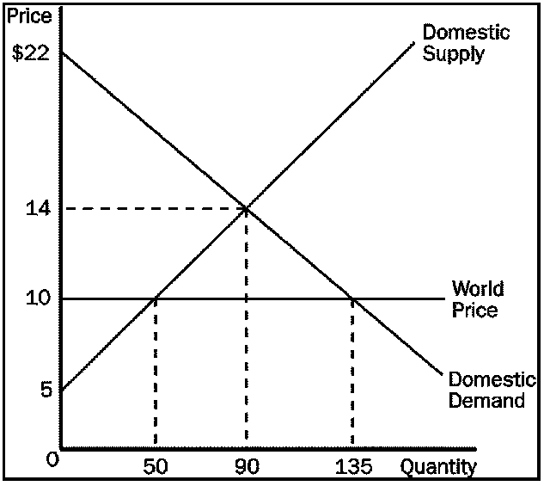

|  |  |
| --- | --- |
| a. | What is the equilibrium price of hammers before trade? |
| b. | What is the equilibrium quantity of hammers before trade? |
| c. | What is the quantity of hammers imported after trade is allowed? |
| d. | What is the amount of consumer surplus before trade? |
| e. | What is the amount of producer surplus before trade? |
| f. | What is the gain from trade to total surplus? |

ANS:

|  |  |
| --- | --- |
| a. | $14 |
| b. | 90 |
| c. | 85 |
| d. | $360 |
| e. | $405 |
| f. | $170 |

Bonus Question (2 points) – What type of good is Spam (the email variety)?

Common Resource