EC 1011

Problem Set 3 – Due 3/7

1.) Using the graph shown below, analyze the effect a $300 price ceiling would have on the market for ten-speed bicycles. Would this be a binding price ceiling?

b. Using the graph shown, analyze the effect a $700 price floor would have on this market. Would this be a binding price floor?

c. Why would policymakers choose to impose a price ceiling or price floor?

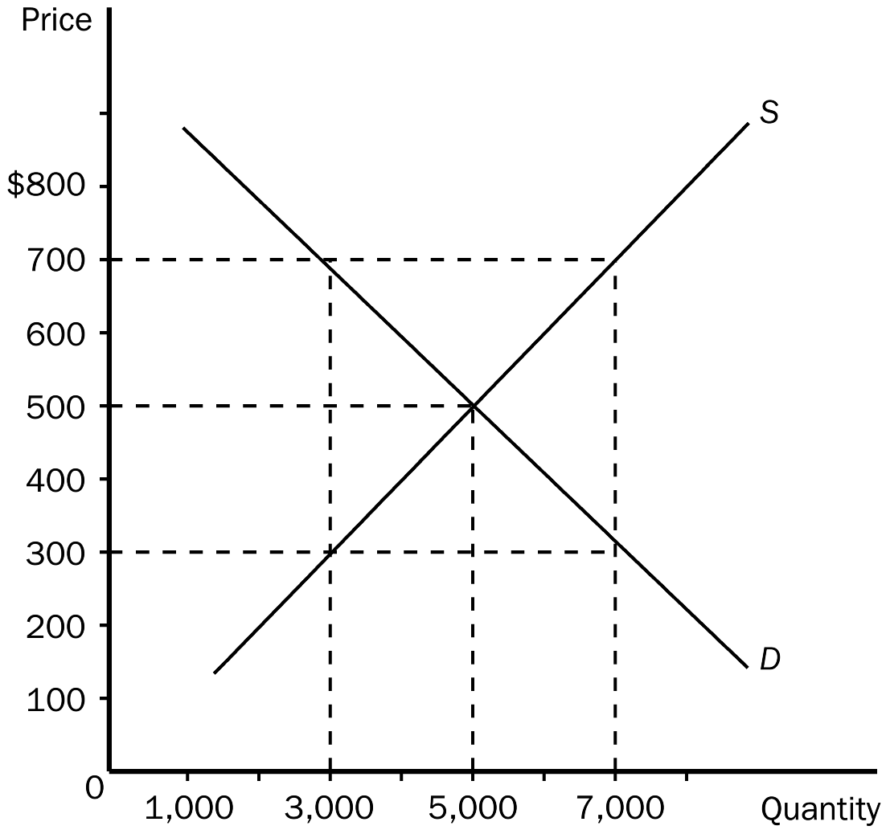

2.) Using the graph shown below, answer the following questions.

a. What was the equilibrium price in this market before the tax?

b. What is the amount of the tax?

c. How much of the tax will the buyers pay?

d. How much of the tax will the sellers pay?

e. How much will the buyer pay for the product after the tax is imposed?

f. How much will the seller receive after the tax is imposed?

g. As a result of the tax, what has happened to the level of market activity?

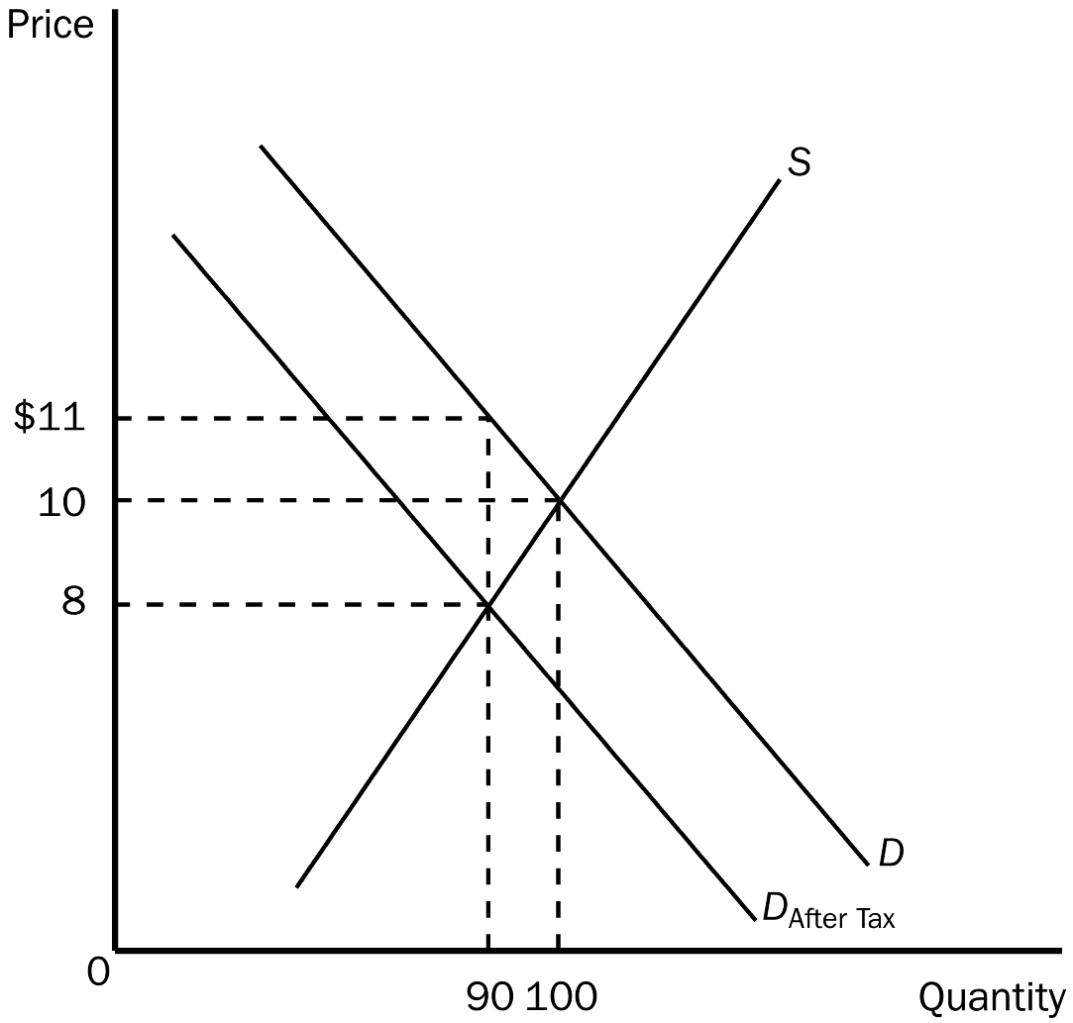

3.) How does elasticity affect the burden of a tax? Justify your answer using supply and demand diagrams.

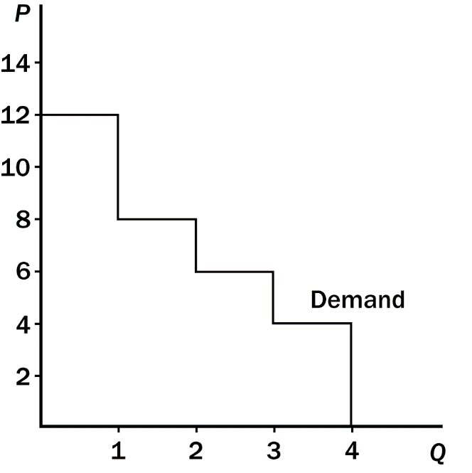

**4.) Refer to the figure above**. If the price of the good is $6, then consumer surplus is what?



5.) Refer to the figure above.

1. What are equilibrium price and quantity?
2. What is consumer surplus in the market at equilibrium?
3. What is producer surplus in the market at equilibrium?
4. What would the quantity bought and sold be if the government sets a price ceiling of $22? Price ceiling of $8?