EC 1011

Problem Set 4 – Due 3/28

1. Refer to the figure below for the following questions:
2. What is consumer surplus at equilibrium?
3. What is producer surplus at equilibrium?
4. What is consumer surplus if the tax shown pushes quantity to 4?
5. What is producer surplus with the same tax?
6. What is deadweight loss?

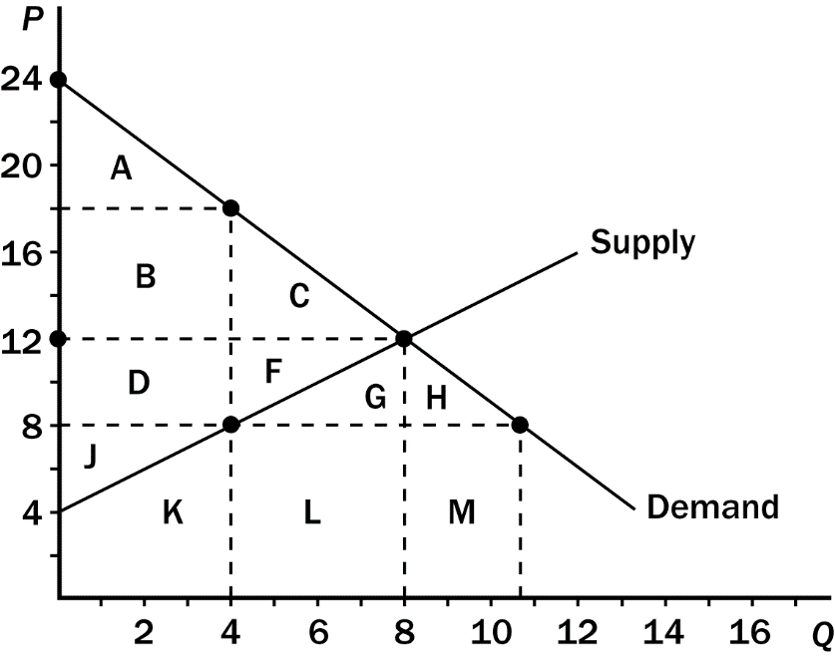

1. John has been in the habit of mowing Hannah’s lawn each week for $20. John's opportunity cost is $15, and Hannah would be willing to pay $25 to have her lawn mowed. What is the maximum tax the government can impose on lawn mowing without discouraging John and Hannah from continuing their mutually beneficial arrangement?
2. Use the graph below to answer the following questions:
3. Without trade, CS is
4. Without trade, PS is
5. With free trade the country will the country import or export the good? How much will be imported or exported?
6. If the country chooses to trade, what is the price of the good?
7. With trade, what is CS?
8. With trade, what is PS?
9. How much does total surplus increase with trade? Does the country have a comparative advantage in this good?

