EC 1011

Problem Set 5 – Due 04/15

1.)





2.) This figure reflects the market for outdoor concerts in a public park surrounded by residential neighborhoods.

***Figure 10-3***

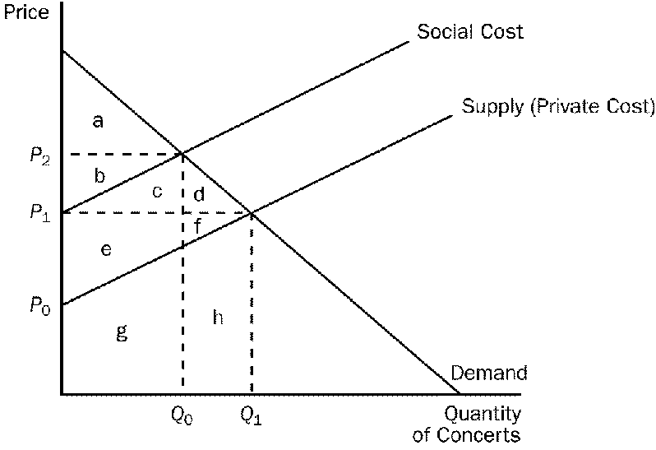

a.) Why is the social cost curve above the supply curve?

b.) The difference between the social cost curve and the supply curve reflects what?

c.) At the private market outcome, the equilibrium price will be what?

d.) What price and quantity combination best represents the optimum price and number of concerts that should be organized?

3.) Many species of animals are common resources, and many must be protected by law to keep them from extinction. Why is the cow not one of these endangered species even though there is such a high demand for beef?